

K4 CSF3133 REKA BENTUK ANTARA MUKA BERASASKAN WEB
LAB REPORT 1
SEMESTER 3

PREPARED FOR: ASSOC. PROF. TS. DR. WAN NURAL JAWAHIR
LAB ASSISTANT: MISS WAN FATIN

PREPARED BY: AKMA ASYIFA BINTI ZULKARNAIE
NO. MATRIC: S75186
SUBMISSION DATE: 22 OCTOBER 2025

1.4 Structure of an HTML Document

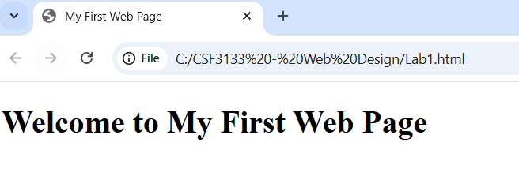
1.5 Basic HTML Tags
1.5.1 Headings

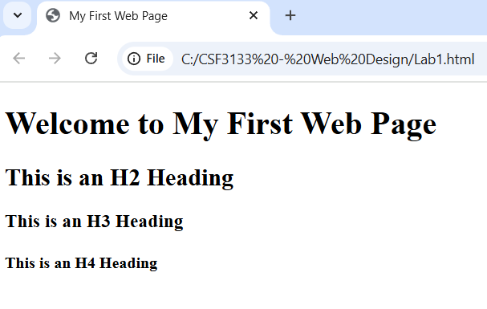
1.5.2 Paragraphs and Text Formatting

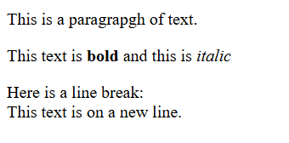

1.5.3 Lists (Ordered and Unordered)

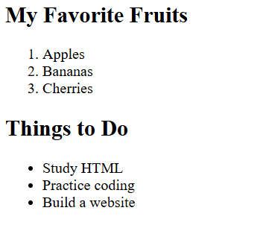
1.6 Links and Images
1.6.1 Add a Hyperlink
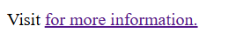
1.6.2 Insert an Image



1.7 Lab Exercise 1
1.7.1 Designing Simple Personal Webpage

HTML code:
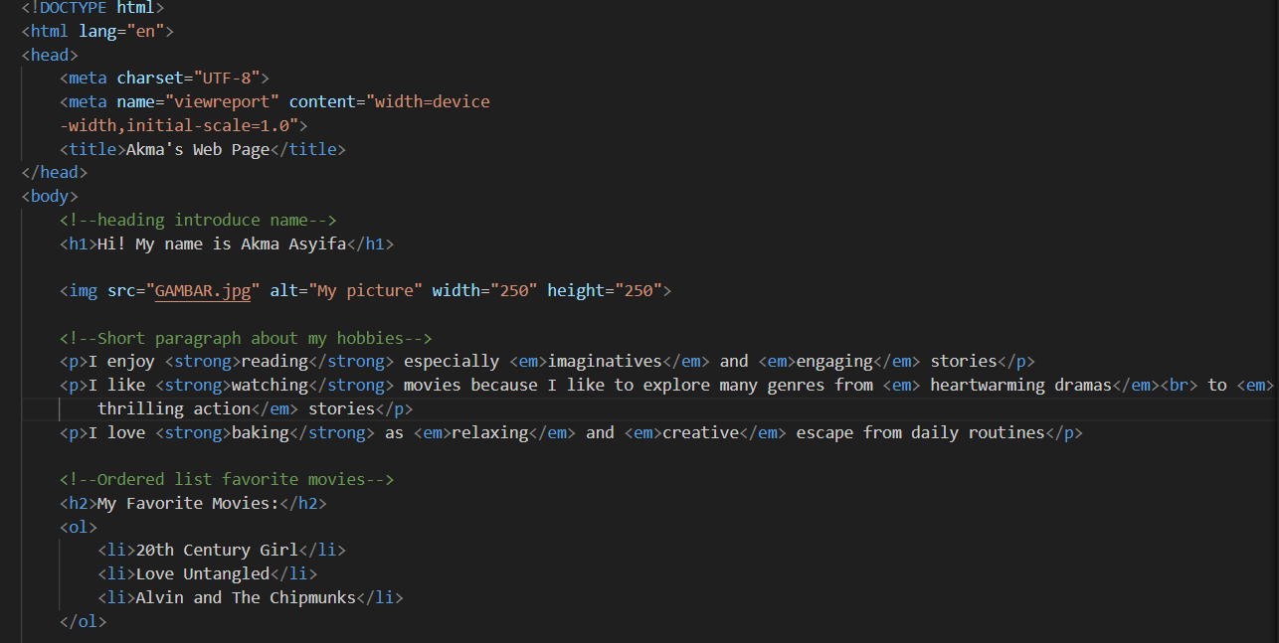
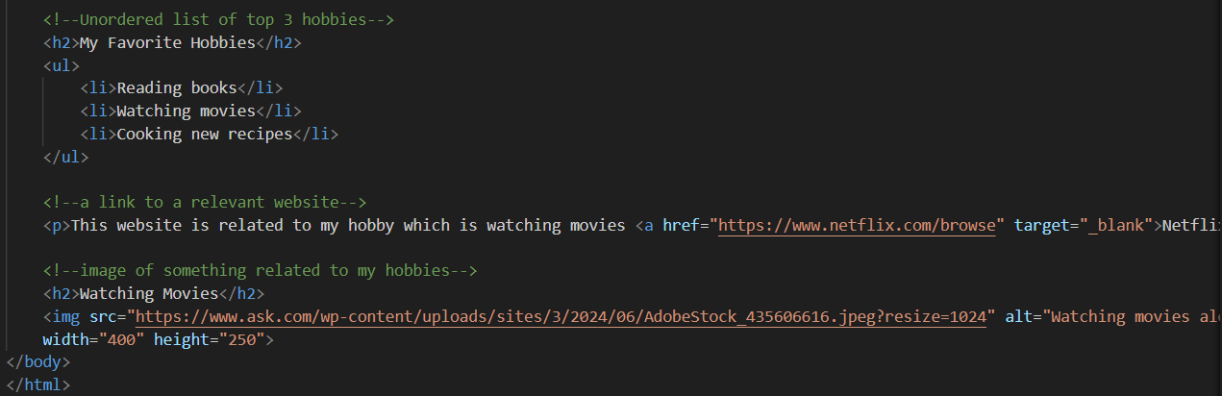

Result:
